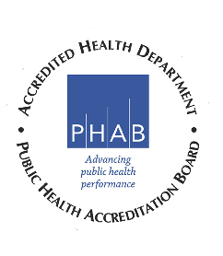

Mississippi Tobacco Control Advisory Council Meeting
Zoom Meeting
Hosted by OTC
Friday, August 21, 2020
11:00 p.m. – 12:00 p.m.

11:00 Introductory Remarks Robert Collins, M.D., Chair

11:05 AG’s Office Update: T21 Bubba Bland, Chief Investigator

11:15 Mississippi Tobacco Quitline – Jeni Klein, Senior Client Services
Services That Save Lives Senior Client Services Manager, Optum

11:35 Legislative Updates Partners
American Cancer Society
American Heart Association
American Lung Association
The Partnership for a Healthy Mississippi

11:45 Business (Old/New)

1:55 Closing Remarks/Comments/Feedback

12:00 Adjourn

Next meeting is scheduled for November 6, 2020
Time: TBA
Location: TBA

