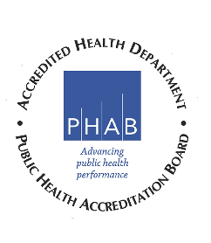

Mississippi Tobacco Control Advisory Council Meeting
Office of Tobacco Control
805 S Wheatley St, Ste 400A
Ridgeland, MS 38967
November 1, 2019
11:00 AM – 2:00 PM

11:00 Introductory Remarks Dr. Robert Collins, Chair

11:10 MSDH updates/E-cigarettes Amy Winter, Director,
Office of Tobacco Control

11:30 Engaging the Behavioral Pamela Luckett, PGL Consulting LLC
Health Community

11:50 MS Youth Programs Update Brenda B Caffe, Executive Director
Caffee Caffee & Associates Public Health Foundation, Inc.
12:05 Networking Lunch

12:40 MS Tobacco Quitline Christie Cresswell, Director, Mississippi
Data and Updates Tobacco Quitline

1:00 Legislative Activities Partners
American Heart Association
American Cancer Society
American Lung Association
The Partnership for a Healthy Mississippi
1:20 Business (Old/New)

1:50 Closing Remarks/Comments/Feedback

2:00 Adjourn

Next meeting is scheduled for February 7, 2020 from 11:00 a.m. – 2:00 p.m.
Location: MSPHI, 829 Wilson Dr. Suite C, Ridgeland, MS 39157

