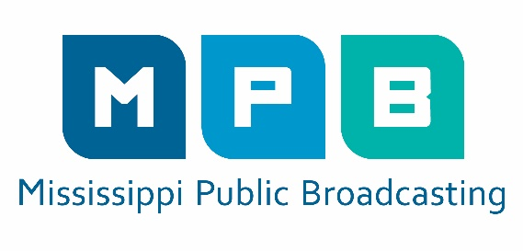
News Release
Feb. 22, 2023
Shelia Byrd
Director of Communications
601-432-6567
shelia.byrd@mpbonline.org

Mississippi Authority for Educational Television Board Meets March 7
Meeting is Open to the Public

JACKSON, Miss. – The Mississippi Authority for Educational Television Board of Directors will meet Tuesday, March 7, 2023, at 10 a.m. at 3825 Ridgewood Road.
The MAET board will conduct business concerning the operations of Mississippi Public Broadcasting. The meeting is open to the public.
For information, call MPB at 601-432-6565. MPB is a state agency that also operates as a PBS and NPR affiliate broadcasting station.
For more information on MPB visit, www.mpbonline.org. Find all MPB press releases here.

###
Mississippi Public Broadcasting provides relevant instructional and public affairs programming to Mississippians through its statewide television and radio network. MPB enhances the work of educators, students, parents and learners of all ages by providing informative programming and educational resources. MPB’s locally-produced programming focuses on the people, resources and attractions that reflect Mississippi’s unique culture and diverse heritage. Children’s television programs constitute a major portion of the daytime and weekend morning schedules. MPB provides a valuable resource to Mississippians in disseminating information as part of the state’s emergency preparedness and response system. Since 1970, MPB has won over 350 national, regional and statewide awards, including Emmy®, Edward R. Murrow and Parents’ Choice® Awards.

