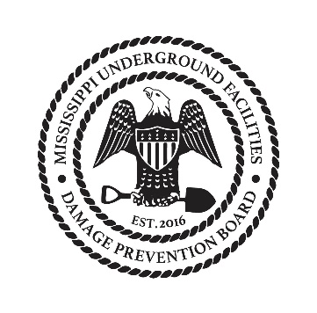
Underground Facilities Damage Prevention Board
Agenda 10-18-2017

- Call to order
- Reading and approval of Minutes from July
- Committee Updates
  - Executive – Complaint status
  - Technical – Updates on web
  - Training – Update on status
  - Financial – Update and Treasurer search
  - Rules and Regulations – Status
- Old business
  - Board reappointment
- New business
- Close

