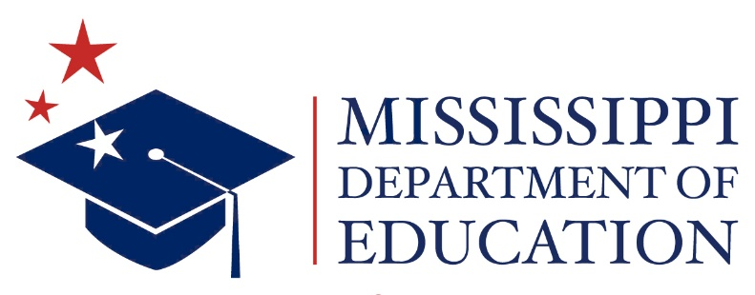

NOTICE

MISSISSIPPI BOARD OF EDUCATION

Internal Accountability Subcommittee Meeting

A meeting of the Internal Accountability Subcommittee of the Mississippi State Board of Education (SBE) will be held at 3:00 p.m. on Thursday August 13, 2026 in Room 212 at the Central High School Building, 359 North West Street, Jackson, Mississippi.

Posted: August 5, 2026

