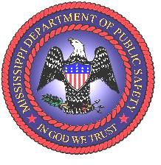
STATE OF MISSISSIPPI
TATE REEVES, GOVERNOR
DEPARTMENT OF PUBLIC SAFETY
SEAN J. TINDELL, COMMISSIONER

Board of Emergency Telecommunications Standards & Training Agenda
May 27, 2026 – 2:00 PM
Emergency Virtual Meeting

- Call to Order
- Roll Call – Establish Quorum / Welcome
  - Prayer
- Approval of Previous Meeting Minutes
  - Approval of Meeting Minutes held on April 8, 2026
- Old Business
  - N/A
- New Business
  - Election of Board Officers
  - High School Work-Based Program
  - “Credits” and “Subject Areas”
  - Course/Vendor Approval Process
  - TCPR and DD-CPR Training Recognition

- Director’s Comments

- Next Scheduled Meeting / Adjournment August 13, 2026

