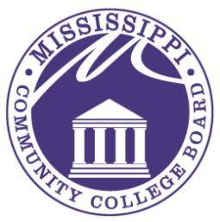
COMMUNITY COLLEGE BOARD
3825 Ridgewood Road Jackson, MS 39211 Phone: (601) 432-6518 Fax: (601) 432-6363

M E M O R A N D U M

TO: Mississippi Proprietary Schools/Colleges/Applicants

FROM: Kim Verneuille, Director
Commission on Proprietary School and College Registration (CPSCR)

SUBJECT: Meeting for Commission on Proprietary School & College Registration

This memorandum is notification of the Commission regular scheduled meeting to be held at 1:00 p.m. Thursday, April 17, 2014 at the Mississippi Community College Board office, located at 3825 Ridgewood Road, Jackson, Mississippi, in the Conference Room located on the 5th floor in Room 507. This meeting may be conducted as a teleconference meeting.

Pursuant to the American Disabilities Act of 1990, should you require reasonable disability accommodations for the above meeting, please contact me in the Proprietary School and College Registration Office at 601-432-6185, at least three (3) days before the meeting date.

The next meeting date is scheduled for June 19, 2014.

