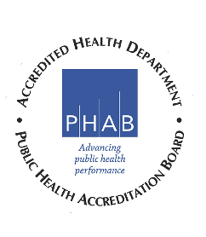
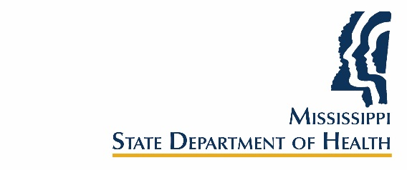

Mississippi Tobacco Control Advisory Council Meeting
Zoom Meeting
Hosted by OTC
Friday, November 6, 2020
11:00 a.m. – 12:00 p.m.

11:00 Introductory Remarks Robert Collins, M.D., Chair

11:05 Catch My Breath Marcella Bianco, CATCH My Breath,
Program Director

11:15 Smoking, Vaping Legislation, Robert McMillen, Ph.D.
Vaping Pathophysiology, Social Science Research Group
COVID-19 & Smoking Vaping

11:35 Legislative Updates Partners
American Cancer Society
American Heart Association
American Lung Association
The Partnership for a Healthy Mississippi

11:45 Business (Old/New)

11:55 Closing Remarks/Comments/Feedback

12:00 Adjourn

Next meeting is scheduled for February 19, 2021
Time: TBA
Location: TBA

