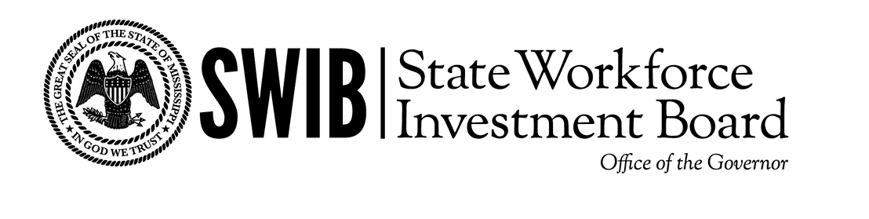
SWIB Executive Committee Agenda
Thursday, December 11^{th,} 2025. 2:30pm
4400 Old Canton Rd. STE 200 Jackson, MS 39211

- Call to Order (Chair, Patrick Sullivan)

- Approval of the Agenda

- Approval of Minutes
  - Approval of Executive Committee Meeting Minutes – September 29th, 2025

- New Business
  - Lightcast Contract

- Executive Director Update

- Executive Session

- Adjournment (Chair, Patrick Sullivan)

