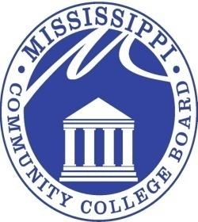

MISSISSIPPI COMMUNITY COLLEGE BOARD

M E E T I N G N O T I C E

FROM: Eric Clark
MCCB Executive Director

RE: Board Meeting Notice

DATE: April 1, 2014

The next regular monthly meeting of the Mississippi Community College Board will be held at 9:00 a.m. CST, Friday, April 11, 2014, in Room 507 of the Education & Research Building, located at 3825 Ridgewood Road, Jackson, Mississippi. This meeting may be conducted as a teleconference meeting.

3825 RIDGEWOOD ROAD, JACKSON, MISSISSIPPI 39211 601-432-6684

