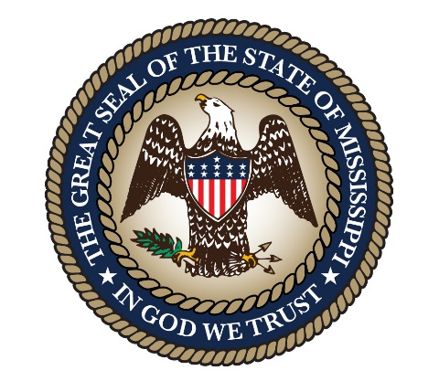

**Mississippi Self-Insured Workers’ Compensation Trust Board**

**Public Meeting Notice**

The next meeting of the Mississippi Self-Insured Workers’ Compensation Trust Board will be held virtually via a Teams Meeting, at 2:30 p.m. on Thursday, August 21, 2025. The call in data is: 601-282-1830#, ID: 806 537 489#.

For further information, contact the Office of Insurance, Department of Finance and Administration at 601-576-2553.