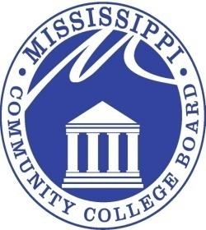

**MISSISSIPPI COMMUNITY COLLEGE BOARD**

# Special Called Meeting Notice

**FROM: Mr. Kell Smith** 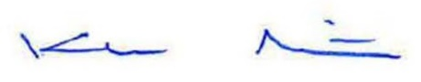

**MCCB Executive Director**

**RE:** **August 7, 2025 Special Called Meeting Notice**

A Special Called meeting of the Mississippi Community College Board will be held at **2:30 p.m. CST, Thursday, August 7, 2025**, in Room 507 of the Paul B. Johnson, Jr. Building, located at 3825 Ridgewood Road, Jackson, MS, 39211. This meeting may be conducted as a teleconference meeting.

The purpose of the Special Called Meeting is to discuss matters concerning ongoing litigation regarding the Board.

3825 RIDGEWOOD ROAD,JACKSON, MISSISSIPPI 39211 601-432-6684